Lab 8
Natnael Kebede
Section 1
- Screen capture showing my name in the XSS reflected tab of DVWA
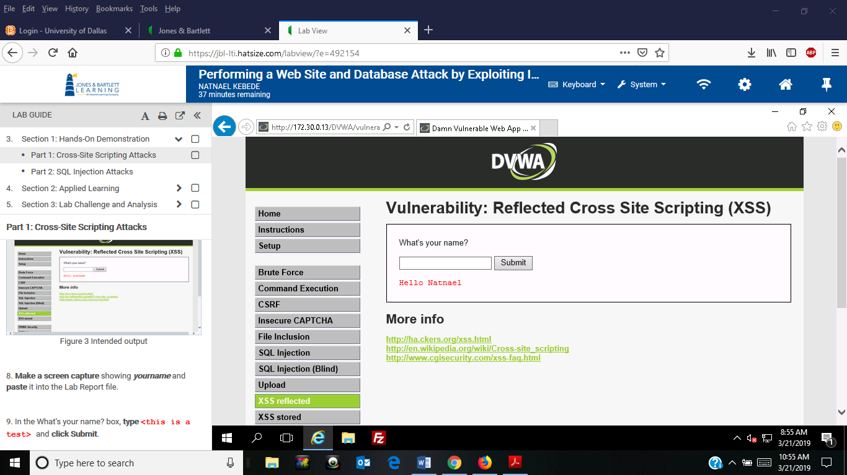
- Screen capture showing exposed vulnerability pop-up alert
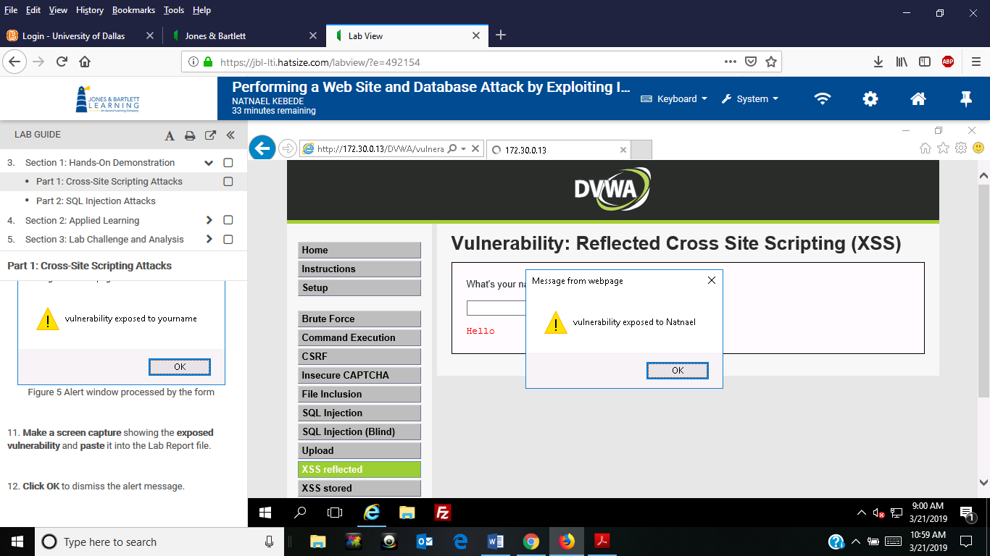
- Screen capture showing SQL injection user hash information
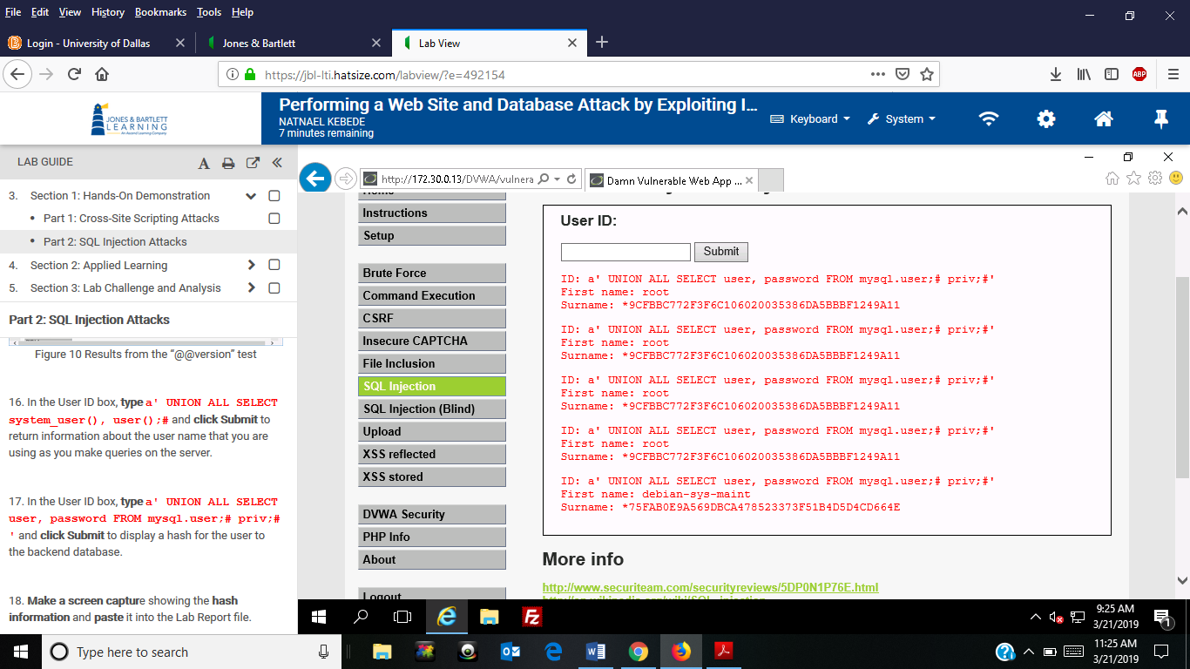
Section 2
- Screen capture showing my name in the XSS reflected tab of DVWA
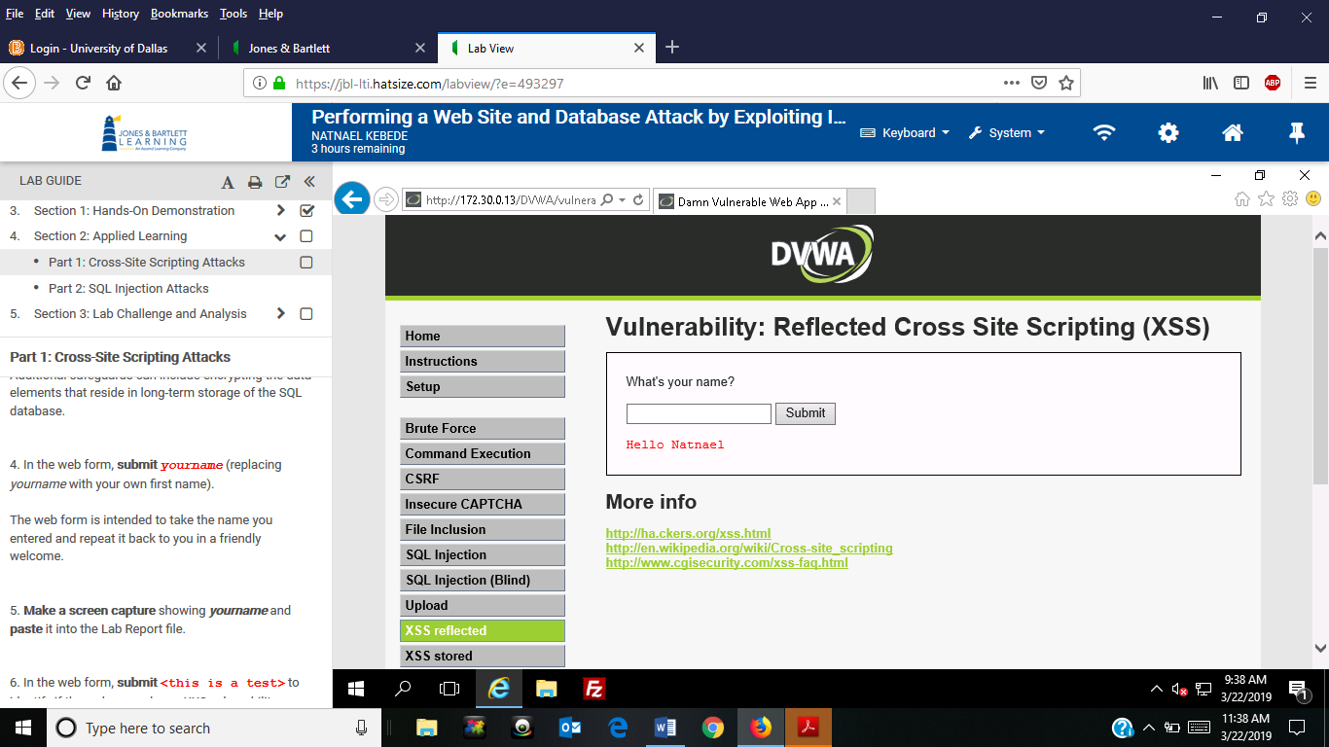

- Screen capture showing exposed vulnerability pop-up alert
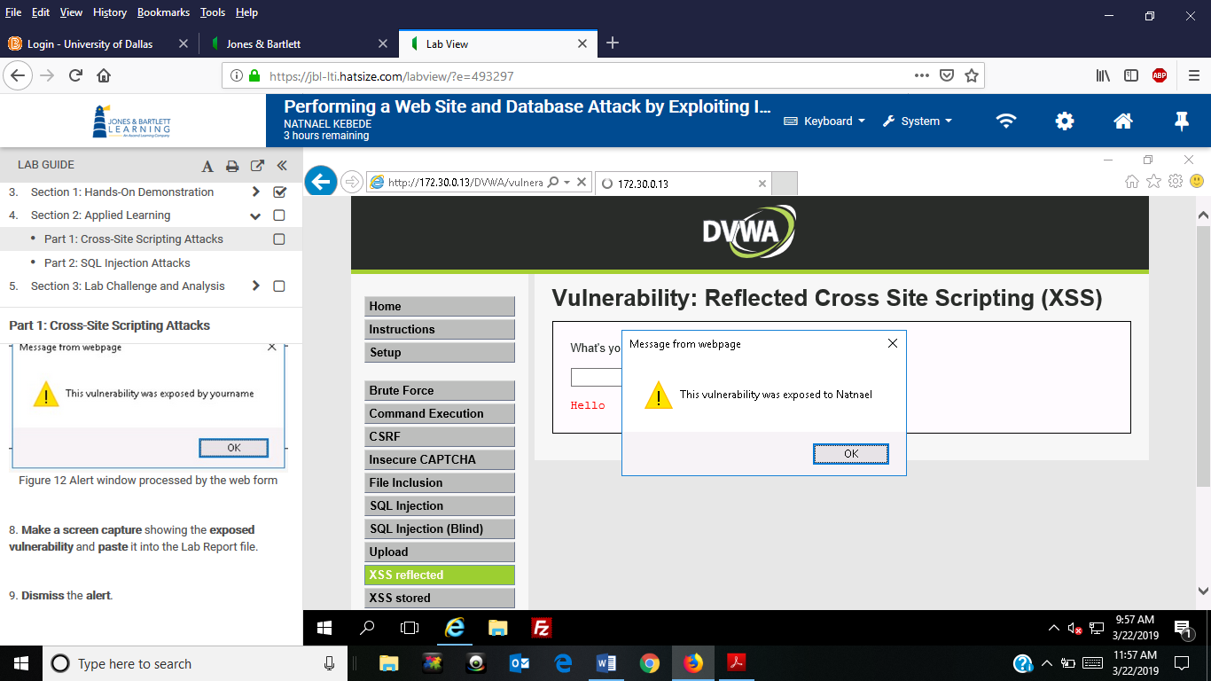
- Screen capture showing submissions that return a response for scripts used to determine the number of columns in a table
- We only get an error message for a’ ORDER BY 3; #
- The other scripts are acceptable in determining the number of columns
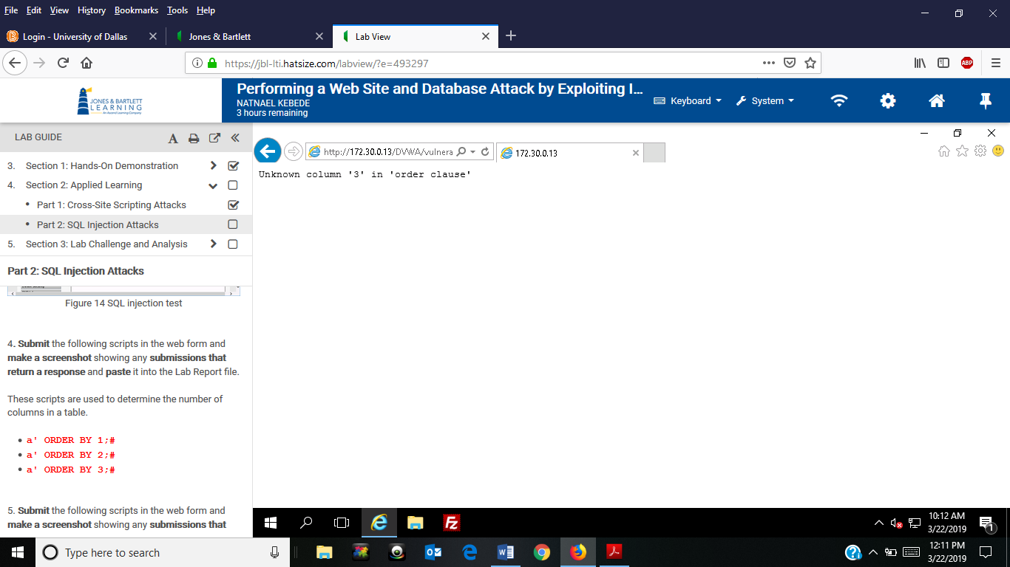
- Screen capture showing submissions that return a response for scripts seeking the correct spelling of a field name
- We only get an error message for a’ OR firstname IS NULL; #
- a’ OR first_name IS NULL; # indicates the filed name is spelled correctly
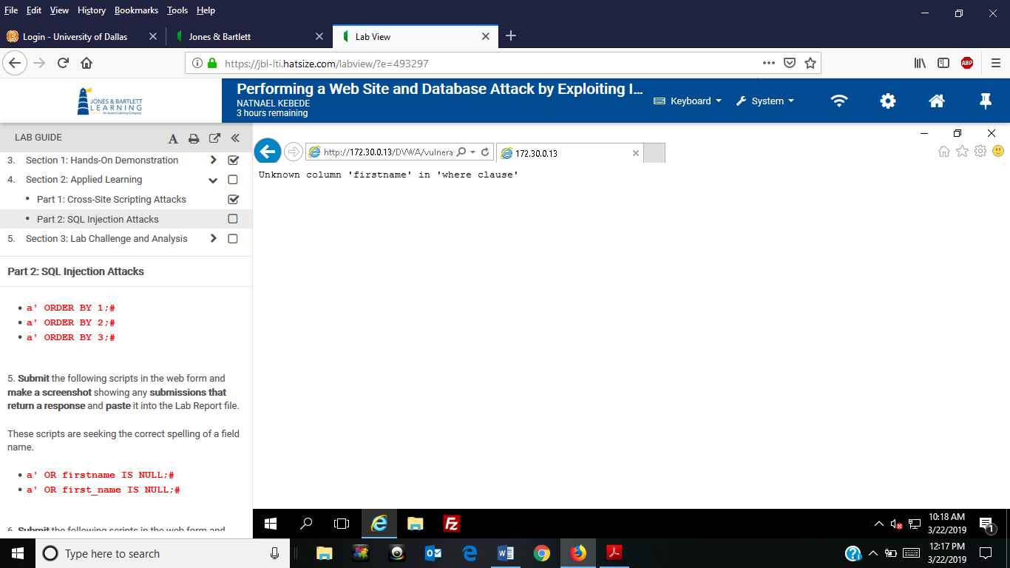
- Screen capture showing submissions that return a response for scripts that search for possible hit on the database’s characters.
- Other script is acceptable but a’ OR database() LIKE ‘d%’ ;# only returns response.
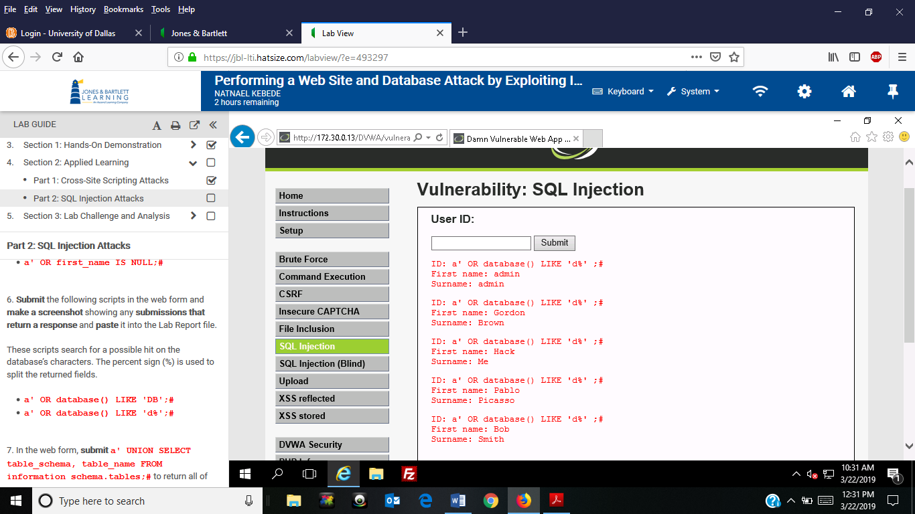
- Screen capture showing SQL injection backend database hash information for current user
